

**LAB 7 REPORT**

NAME : NURSYAFIQAH IZANI BINTI MOHD ZAIN

MATRICS NUMBER : BI19110120

IC NUMBER : 001230120206

COURSE : KK14203

LECTURER : Dr Samrie @ Mohd Shamrie Sainin

1) Add Menu Bar at the top with menu ‘Load Data’ to read from file and view in the output textrea. Menu ‘Exit’ to show ‘showConfirmDialog’ and exit the application if user select ‘yes’ in the dialog.

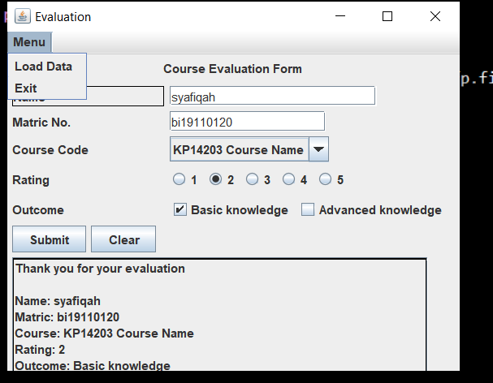

When click load data, it will show the output in text area

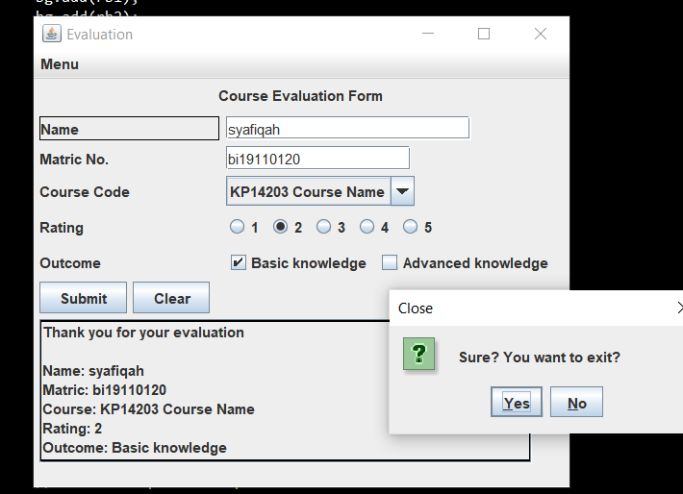

When click exit, it will show the confirm dialog

2. Input validation from all input to check if user empty field or selections when user click ‘Submit’ button.

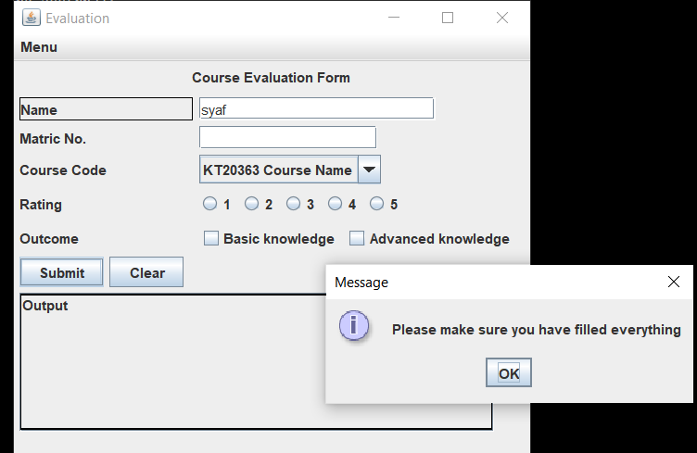

3. Save (add) the data into a text file with dialog notification (e.g. showMessageDialog) whether input is successfully saved.

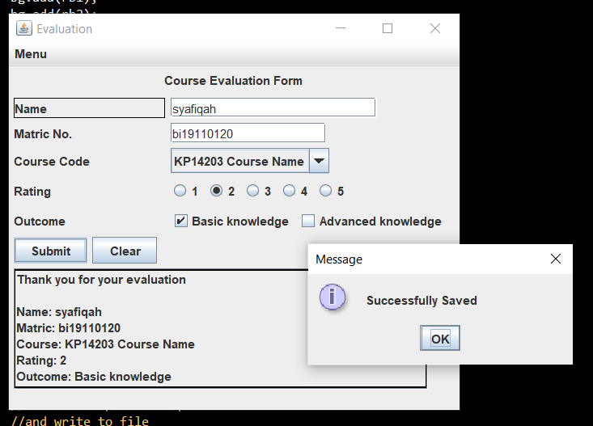

4. Implement at least ONE (1) exception handling (e.g. file IO and dealing with empty input field.

